Sony Xperia 10 II

Phone Photos

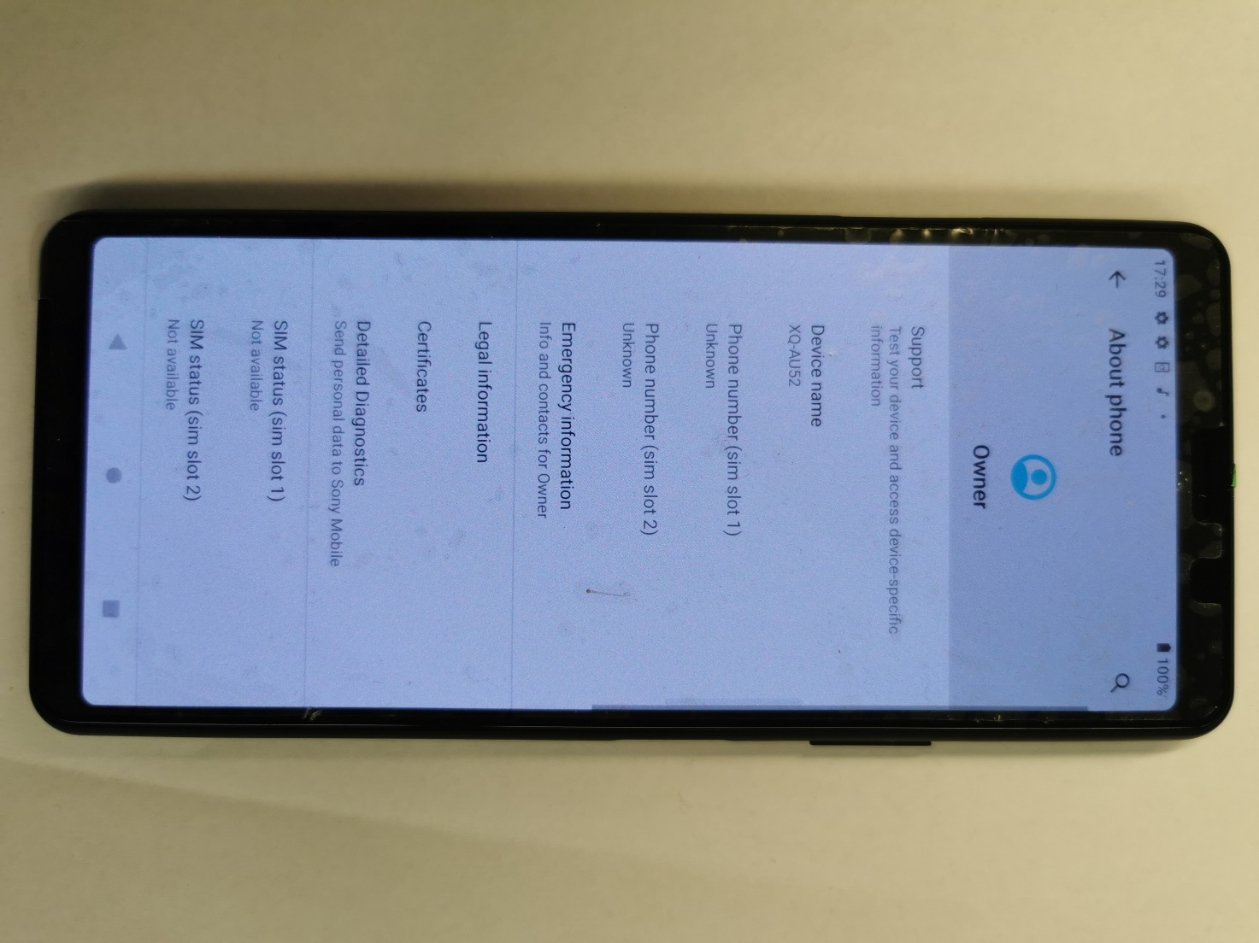

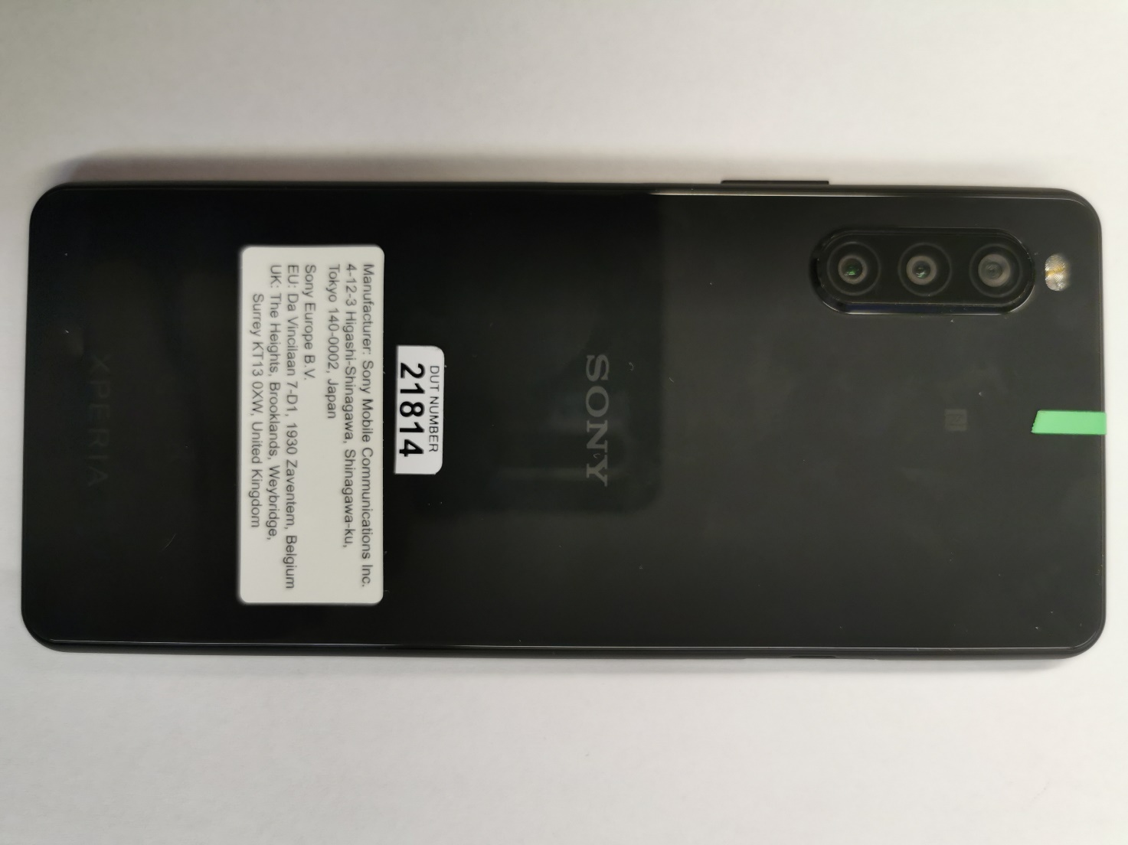

Sales package information Photo

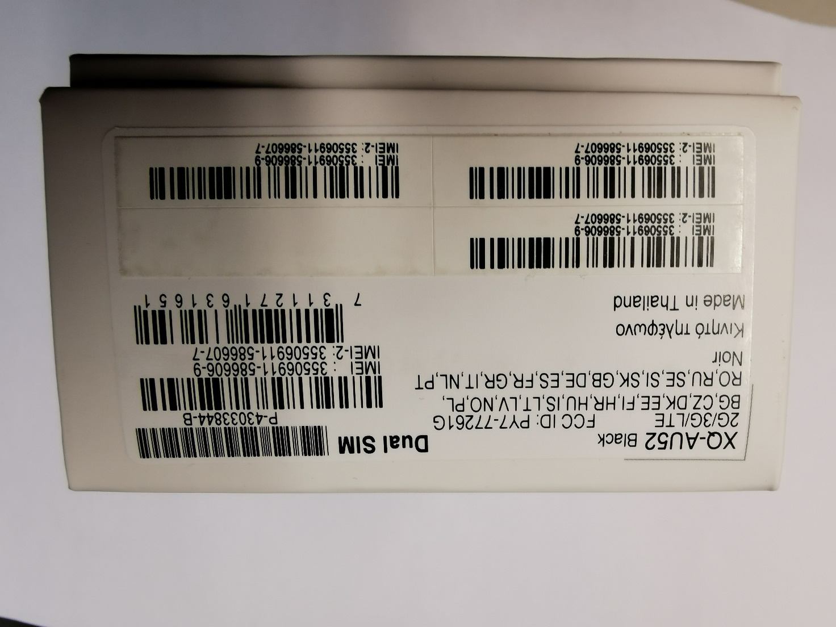

Guide photos

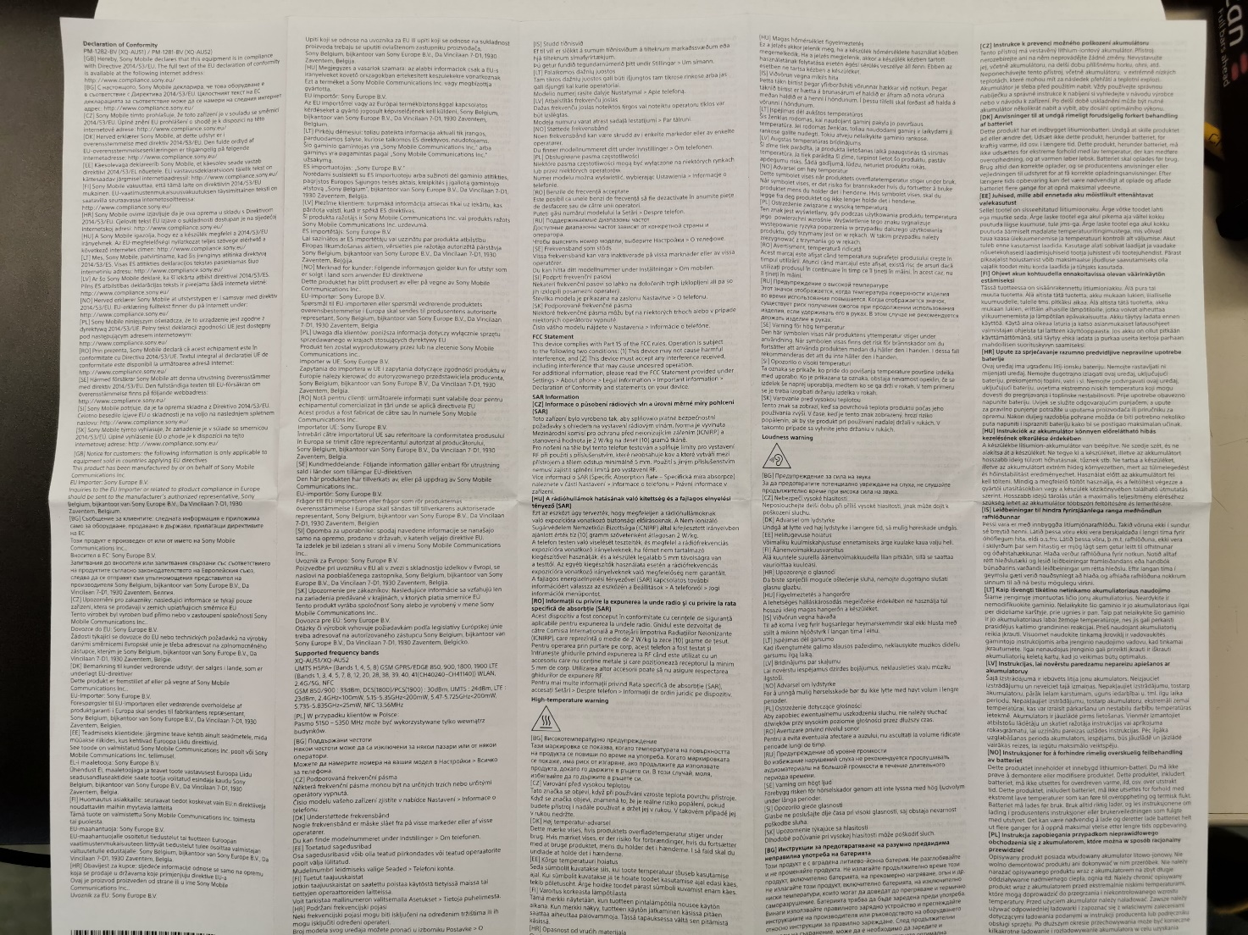

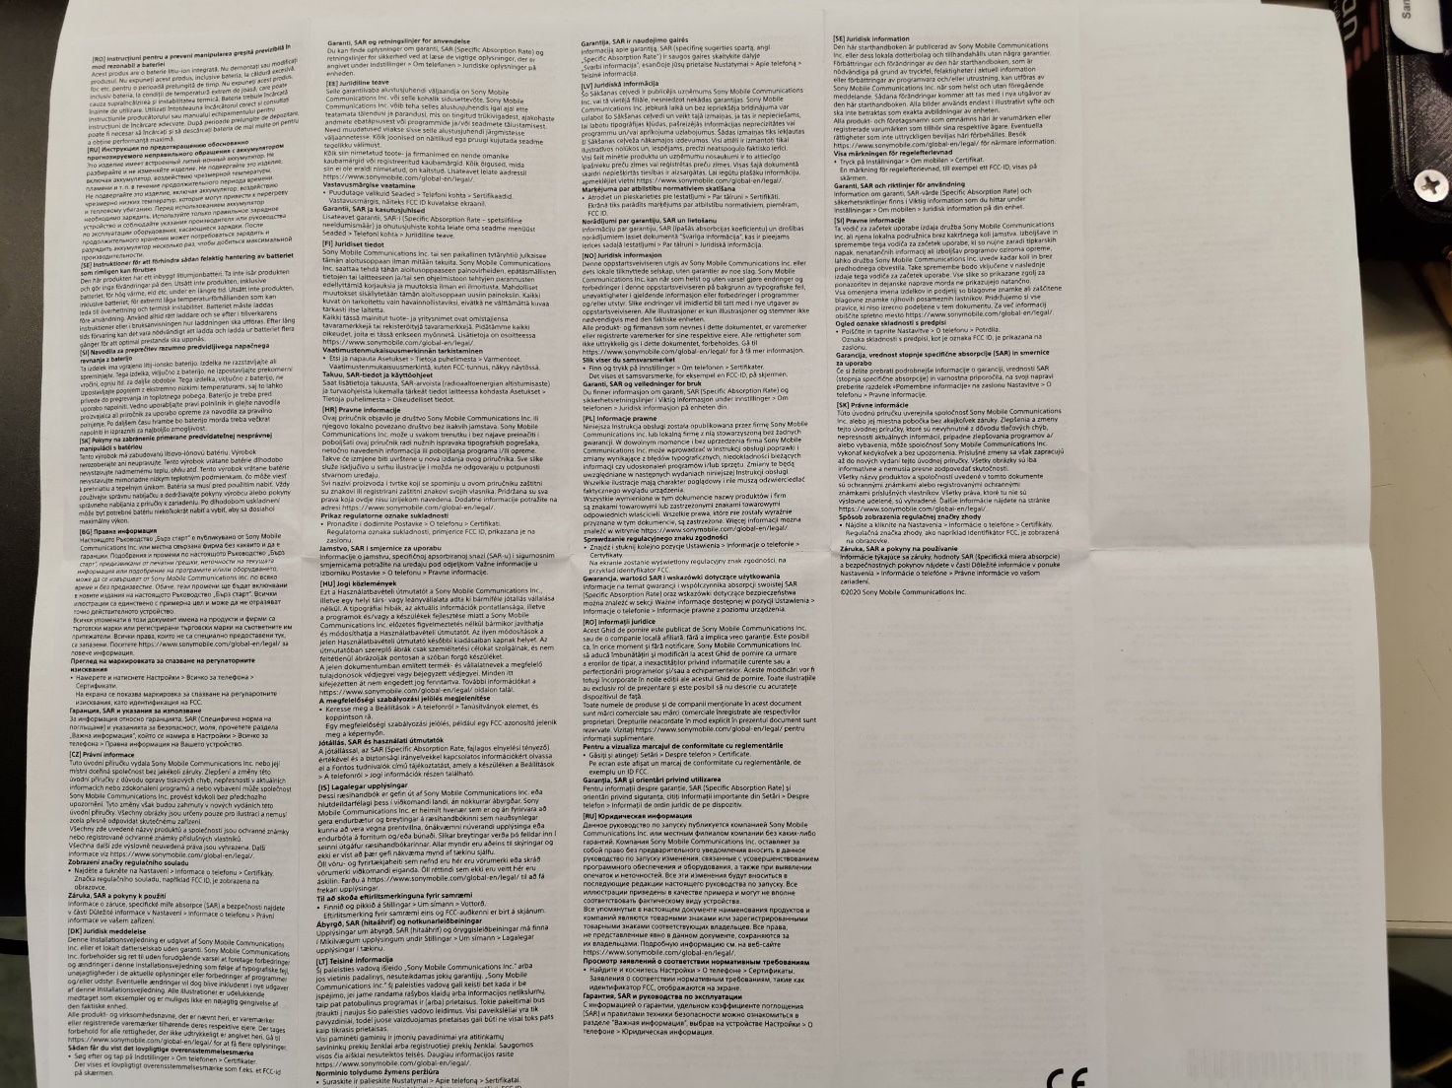

Safety Information
Can be downloaded for Samsung website:

https://www.sony-asia.com/electronics/support/mobile-phones-tablets-mobile-phones/xperia-10-ii/manuals

Screenshot pictures from phone

About Phone > Legal Information > Important Information 